Preparations for War??
July 7, 2017
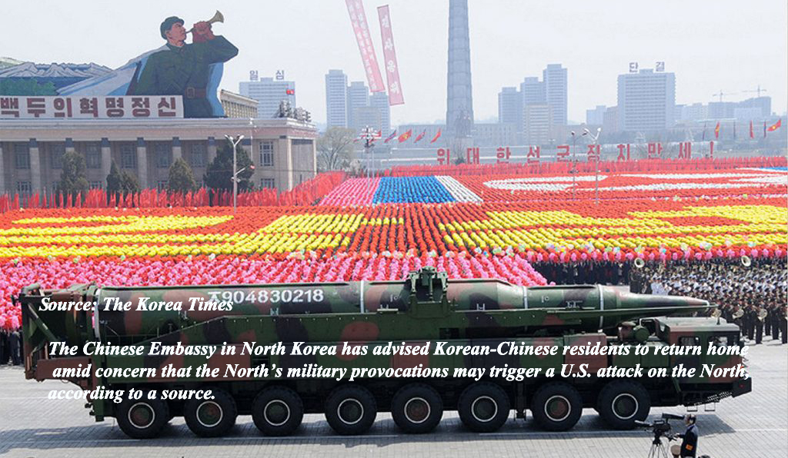
May the peace and wisdom Jesus gives us in His intimate presence prevail over every fear and anxiety. Amen

Dear Heartdwellers, forgive my small absence while we move our office into Ezekiel’s room and move him into the old office. It is quite an ambitious undertaking, since we are well stocked with survival items to give away on that Day. So, first we had to find a place to put those. We had to organize a storage shed before we could even think about moving anything.

But somehow we are making progress. However, not without me being absent from you. Please pray this will be over quickly?!

After communion the Lord pulled me aside for this word. Interestingly, I wasn’t thinking about this at all. It came as quite a surprise.

Jesus began, “There are many preparations for war being made, but they will not be completed anytime soon. Your whole armed services must be revamped, re-dedicated, healed and restored. This process is underway but is lengthy and takes time. They are no position right now to launch an aggressive attack. So, they are biding their time and rebuilding.

"Nevertheless, the threat of war is always present. What I need you and all Heartdwellers to understand is that nothing happens without My permission and as long as you are all praying and living a life-style of carrying your cross with thanksgiving, I will not give the word.

"Many follow the news and then imagine I am talking to them—when in fact it is in their own heads. That is why internet prophets seem to have the same message. It is a group consciousness, based on what they are fed through the news, even the resistance news. It should be, but is not obvious to most, that excitement attracts listeners, who want to continue to hear the excitement—so they support these channels.

"Heartdwellers, I want to be your 'channel/. I want you to come out of your prayer closets with a “knowing” of what is going to happen and what is not going to happen. But instead of that, many of you still follow the exciting newsy channels that stir your emotions and give you hope that I’m coming tomorrow. Don’t you see what a waste of time this is?

"What I want you to be excited about is your gift, its cultivation and the impact on the lost. That’s what truly is exciting to Me. Intercession is tremendously exciting to Me. And also why I have My Divine finger in the dyke, holding back what the ruling elite have planned to carry out. They cannot carry it out without My permission and if you are pressing into Me in prayer and intercession, you will come out of prayer with this sense and the inspiration to move forward with your particular gift, rather than to postpone or tread water waiting for the war to start.

"Well, I know you are tired of Me saying this, but in this particular moment, it needed saying. Press into Me while you are waiting for that day. Let Me dance with you, hold you and empower you with inspiration. How I love you! How I wish the day were closer. But there are still many souls ripe for conversion. Come to Me praying, resting and expecting to be renewed.

"Graces to overcome old problems and setbacks are being released. There is excitement within the Body of Believers that truly has their finger on My pulse. The gifts are multiplying. Those who have been faithful and persevering in the little things will be given more. Barriers are being overcome with grace and I am rewarding My faithful ones.

"Do not expect this to come with a free ticket. There will still be challenges and opposition. You are targets more than ever now, because you have blasted through the enemies' defenses and taken ground through My anointing.

"You will have struggles but you are more equipped now than ever to resist evil and continue on with My blessing. Continue to build with one hand and wield the sword with the other. Where there is great spiritual treasure, there is great spiritual opposition and plans to steal it. Therefore, remain vigilant and stand your ground as you pass on higher and higher in your callings."

And that was the end of His message.

I wanted to share with you that I still am having big opposition against music and I finally broke down and cried and said, 'Lord I can’t do this unless you do it through me.'

God the Father visited me and gave me a very special boost, which I am totally enjoying. But even at that the next day the enemy was trying to steal it from me through discouragement. And I had to lay everything aside and dwell in the Lord’s presence for most of the day and night. Yes, hours and hours and hours—and how wonderful it was.

I am seeing what my problem is. I am in the world way too much. In this context, it was just orchestrating things around the property and getting ready for our little move; that’s the world I’ve been into too much. Being in the world so much causes me to have a more worldly attitude about failure and success. My understanding of exactly Who God is and what He says He will do was waning.

So, I am passing this insight onto you. You cannot withstand the heat of opposition unless you are substantially in the Lord’s presence, absorbing His love, anointing and thoughts.

“My thoughts are not your thoughts.” says the Lord. Isaiah 55:8

And when we hang out with the world we begin to think and feel like the world. It's the kind of thinking where we see that nothing gets done unless WE do it. That works okay for doing the dishes or what have you. But in the greater context, that leaves God out of the mix totally. Because we are thinking of what WE can do - not about what God can do through us. So we begin to get a little independent and self-sufficient. And then we see our weaknesses. They catch up with us and we say, "Oooohhh boy! I can't do this on my own." And then it hits us: we're not alone. The Lord will do this through us. For us to have that confidence and faith, we really have to dwell in His presence, receive His heart from Him and be infused with His anointing.

And the enemy uses distractions to keep us out of dwelling prayer. This is what happened to me. I allowed the dramas around me to distract me. Now I am clamping down and separating myself from these distractions—and it's really helping.

Whenever you feel failure, discouragement and lackluster, it’s always a sign of a failing connection with Jesus. Our spiritual batteries are running on low and about to go out. So, we need to recognize why we are waning. Our connection to the electricity was too long ago; we need to plug in again and get recharged.

Just as the Lord said, “I am the vine, you are the branches. Unless you abide in Me you cannot bear fruit.” John 15:5

The Lord bless you, dear Heartdwellers. Let's press in His heart and allow Him to exchange our weakness for His strength. Amen.

